**Model Development Phase Template**

|  |  |
| --- | --- |
| Date | 20 June 2024 |
| Team ID | 739900 |
| Project Title | Predicting Permanent Magnet Resistance  Of Electronic Motor Using Machine Learning |
| Maximum Marks | 4 Marks |

**Initial Model Training Code, Model Validation and Evaluation Report**

The initial model training code will be showcased in the future through a screenshot. The model validation and evaluation report will include classification reports, accuracy, and confusion matrices for multiple models, presented through respective screenshots.

**Initial Model Training Code:**

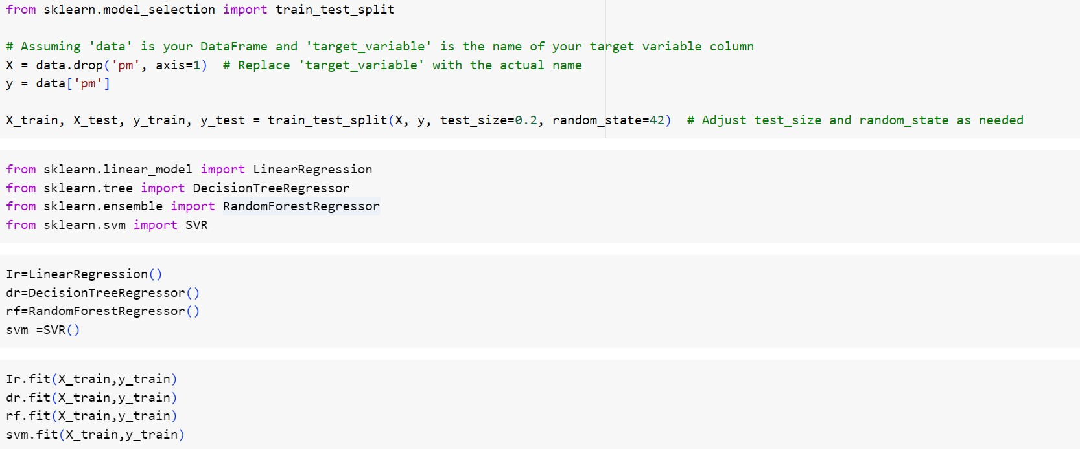

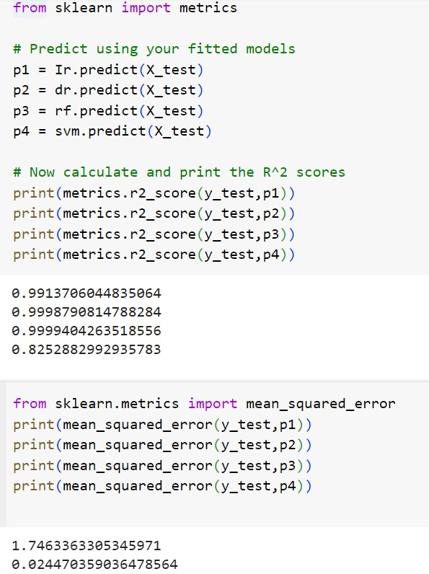

|  |  |  |
| --- | --- | --- |
| **Model** | **Mean Squared Error** | **R2-Score** |

|  |  |  |
| --- | --- | --- |
| Decision tree,linear regression,randomforest regression |  |  |